**Tabs**

Following snapshots shows different tabs on one screen, by clicking each tab you can see respective page for that tab as you navigate through it.

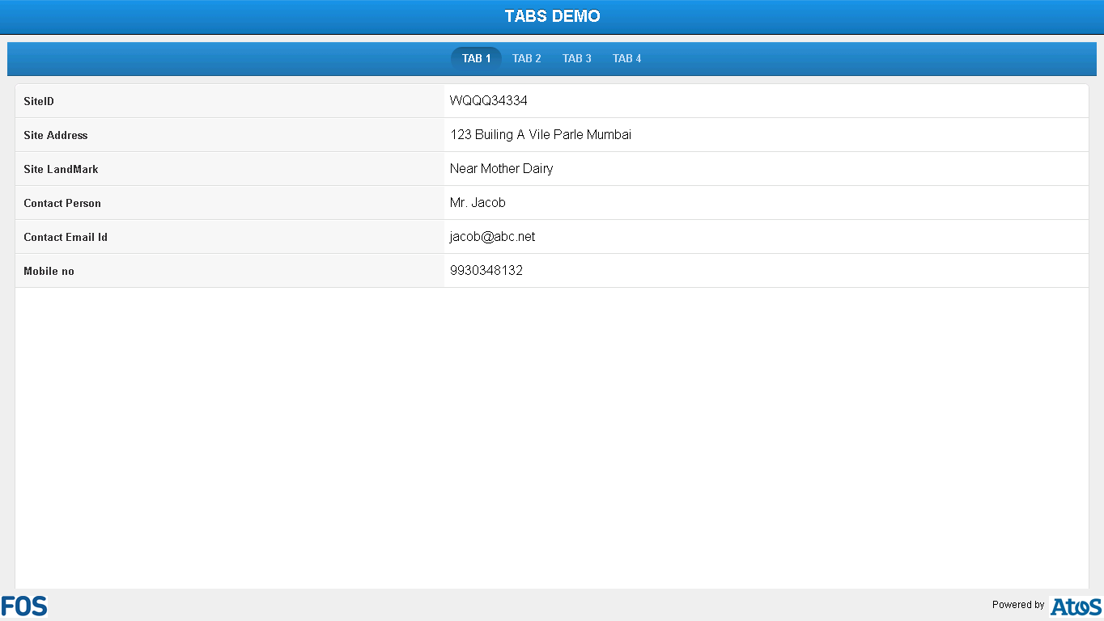

**Snapshot 1.1**

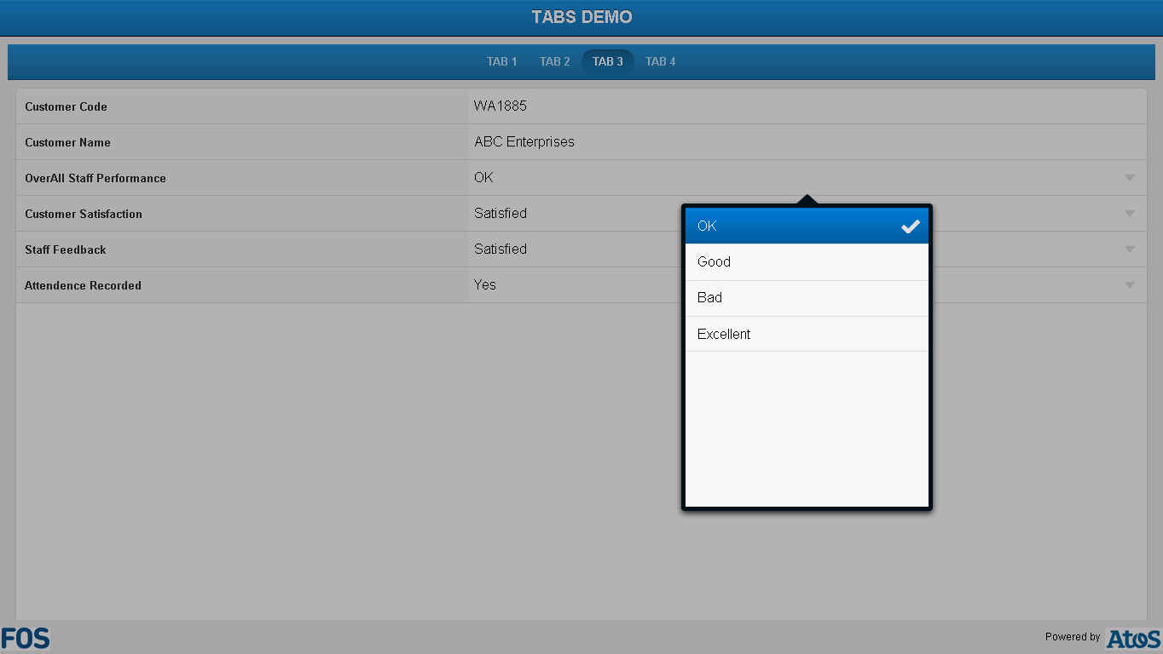

**Snapshot 1.2**

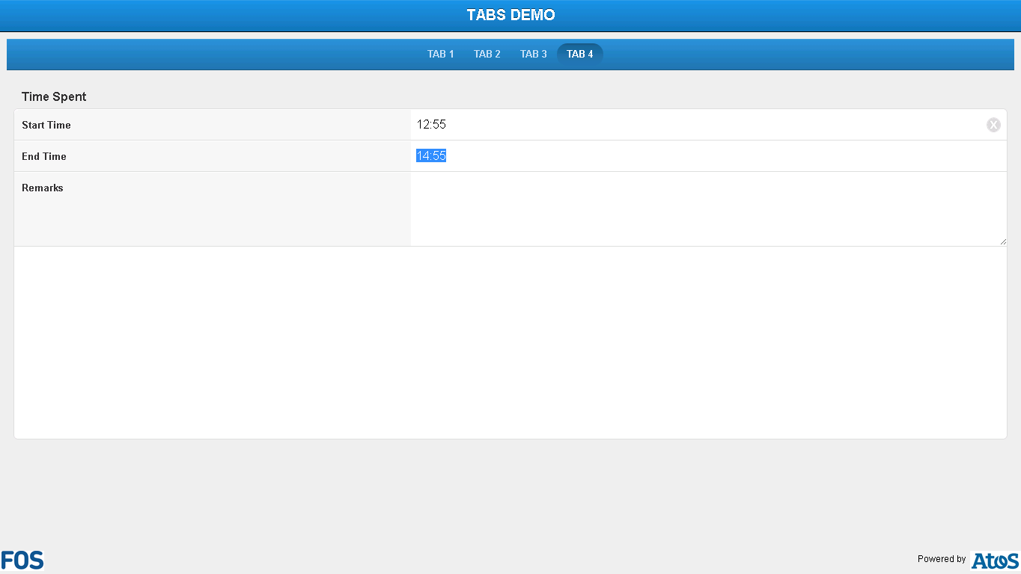

**Snapshot 1.3**

**Code**

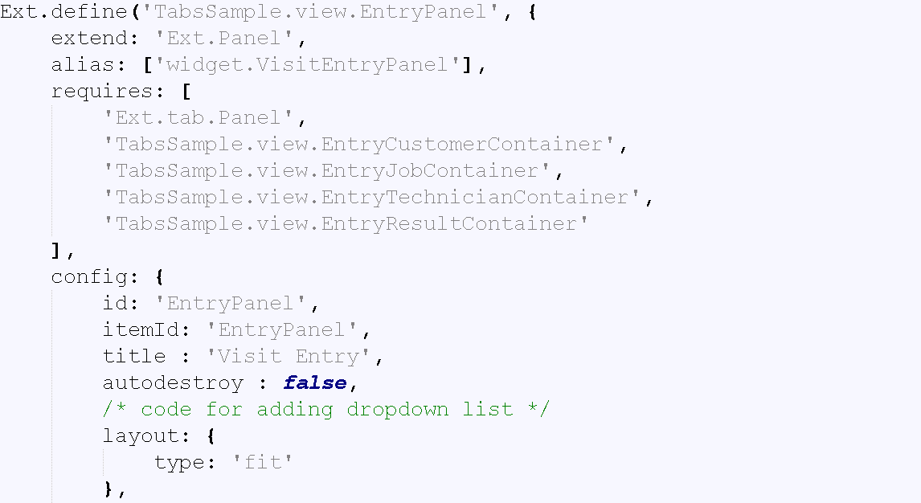

**Snapshot 1.4**

**Ext.define('TabsSample.view.EntryPanel',** :-> Here, name of application is defined

**{**

**extend: 'Ext.Panel',** :-> Here, class extends to super class panel to use in your application.

**alias: ['widget.VisitEntryPanel'],**

**requires: [** :-> requires blocks contains files which you require for you tab sample example, here various view files are added to show at different tabs.

**'Ext.tab.Panel',** :-> Super class for tab panel

**'TabsSample.view.EntryCustomerContainer',** :-> Class defined to view folder to use in tab 2

**'TabsSample.view.EntryJobContainer',** Class defined to view folder to use in tab 3

**'TabsSample.view.EntryTechnicianContainer',** Class defined to view folder to use in tab 1

**TabsSample.view.EntryResultContainer'** Class defined to view folder to use in tab 4

**],**

**config: {**

**id: 'EntryPanel',**

**itemId: 'EntryPanel',**

**title : 'Visit Entry',**

**autodestroy : false,**

code for adding dropdown list

**layout: {**

**type: 'fit'**

**},**

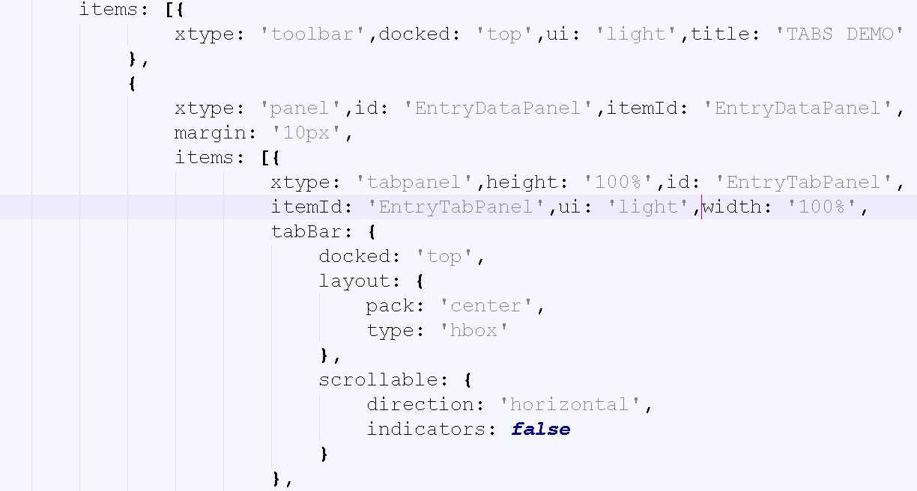

**Snapshot 1.5**

**items: [{** :->Definition Title bar

**xtype: 'toolbar',docked: 'top',ui: 'light',title: 'TABS DEMO'**

**},**

**{**

**xtype: 'panel',id: 'EntryDataPanel',itemId: 'EntryDataPanel',**

**margin: '10px',**

**items: [{** :-> Here, tabpanel is added below title bar.

**xtype: 'tabpanel',height: '100%',id: 'EntryTabPanel',**

**itemId: 'EntryTabPanel',ui: 'light',width: '100%',**

**tabBar: {** :-> Layout for tab bar

**docked: 'top',**

**layout: {**

**pack: 'center',**

**type: 'hbox'**

**},**

**scrollable: {**

**direction: 'horizontal',**

**indicators: false**

**}**

**},**

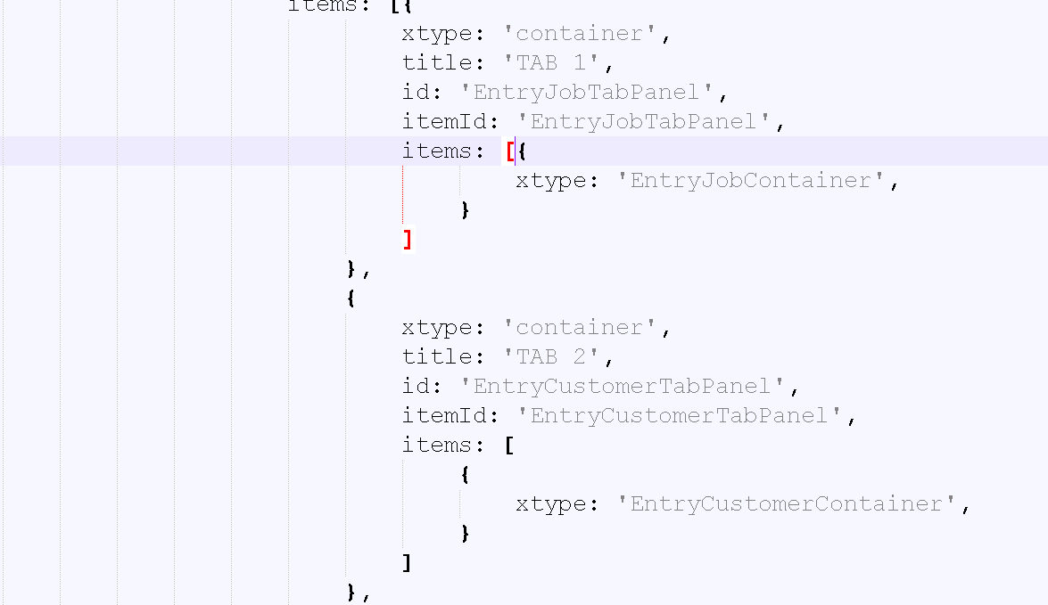

**Snapshot 1.6**

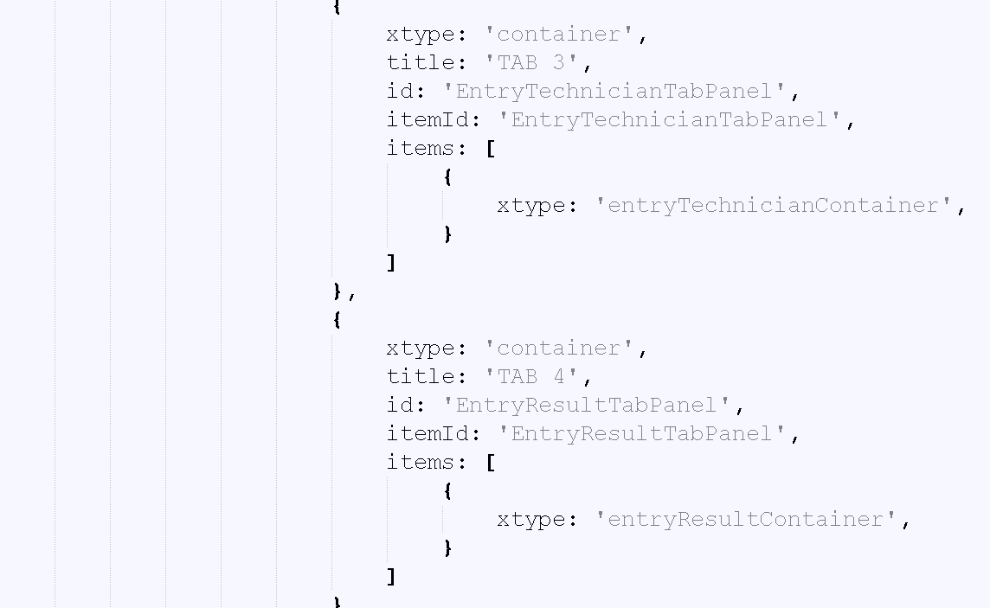

**Snapshot 1.7**

Following items are added as four different tabs on panel

**items: [**

:-> This is code for tab1, which includes id for EntryJobTabPanel as a container which is defined in view folder with xtype as ‘'EntryJobContainer'’ which will include this particular file in tab 1, same is done for tab2, tab3 and tab4.

**{**

**xtype: 'container',**

**title: 'TAB 1',**

**id: 'EntryJobTabPanel',**

**itemId: 'EntryJobTabPanel',**

**items: [{**

**xtype: 'EntryJobContainer',**

**}**

**]**

**},**

**{**

**xtype: 'container',**

**title: 'TAB 2',**

**id: 'EntryCustomerTabPanel',**

**itemId: 'EntryCustomerTabPanel',**

**items: [**

**{**

**xtype: 'EntryCustomerContainer',**

**}**

**]**

**},**

**{**

**xtype: 'container',**

**title: 'TAB 3',**

**id: 'EntryTechnicianTabPanel',**

**itemId: 'EntryTechnicianTabPanel',**

**items: [**

**{**

**xtype: 'entryTechnicianContainer',**

**}**

**]**

**},**

**{**

**xtype: 'container',**

**title: 'TAB 4',**

**id: 'EntryResultTabPanel',**

**itemId: 'EntryResultTabPanel',**

**items: [**

**{**

**xtype: 'entryResultContainer',**

**}**

**]**

**}**

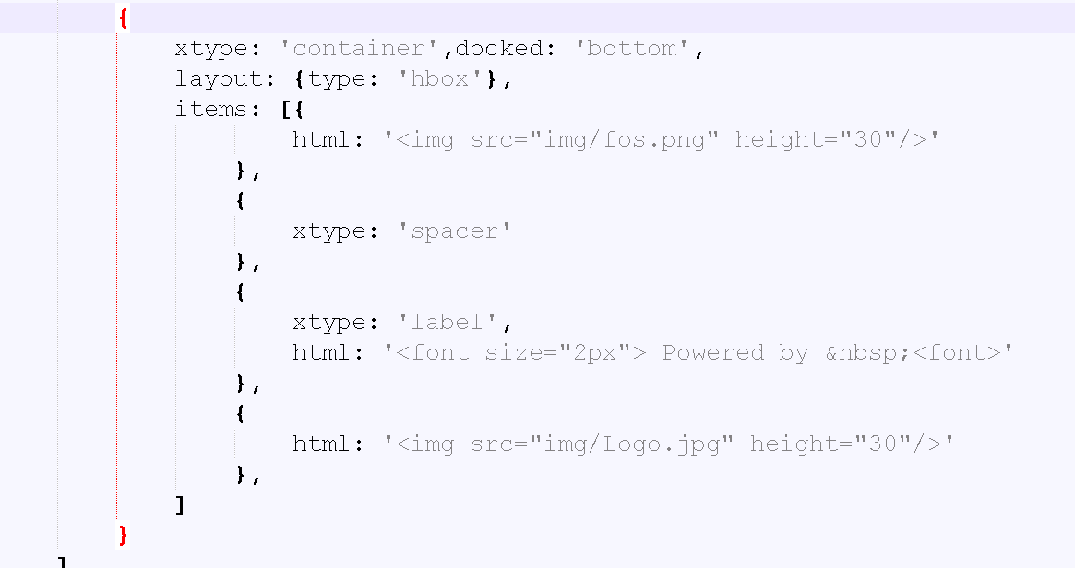

**Snapshot 1.8**

**{** :-> This is container which includes images at bottom of main panel

**xtype: 'container',docked: 'bottom',**

**layout: {type: 'hbox'},**

**items: [{**

**html: '<img src="img/fos.png" height="30"/>'** :->HTML code to added image in sencha code

**},**

**{**

**xtype: 'spacer'**

**},**

**{**

**xtype: 'label',**

**html: '<font size="2px"> Powered by &nbsp;<font>'**

**},**

**{**

**html: '<img src="img/Logo.jpg" height="30"/>'**:->HTML code to added image in sencha code

**},**

**]**

**}**

**FAQ**

**Checkpoints:**

1. Check carefully with your indentations as if you will miss any of the braces by mistake may reflect in compilation error.
2. See that your .js file starts with Ext.Define block and check that ends at the end of the program.
3. More than one items are separated by comma (,) separator and main program block of define is ended by semi colon (;)
4. Any value is assigned using colon (:) for example ui: 'confirm' and value is written inside single coats.
5. Items block starts with square brackets [] , which contains multiple members and also sub items.
6. Don’t forget to add entries of your files in app.js.
7. Here, img folder is added to main application folder which contains images used in tabs sample app.

**Source Code**

